**Practical Activity 5**

Sally Oketch.

[Sally.oketch@womentechsters.org](mailto:Sally.oketch@womentechsters.org)

Assuming you are a system administrator in “CarMax” Car Dealership and you have been assigned with a task to add 1 Headquarters and 2 Sales Locations in a windows Server 2016 you configured.

1. **With the help of Active Directory, Add the Headquarters and 2 Sales Locations.**

Go to the active directory users and computers tab and create an organizational unit called CARMAXHQ to represent the headquarters.

In CARMAXHQ three organizational units to represent Administration department, Accounting department, HR and two different locations which I named Kisumu and Nairobi.

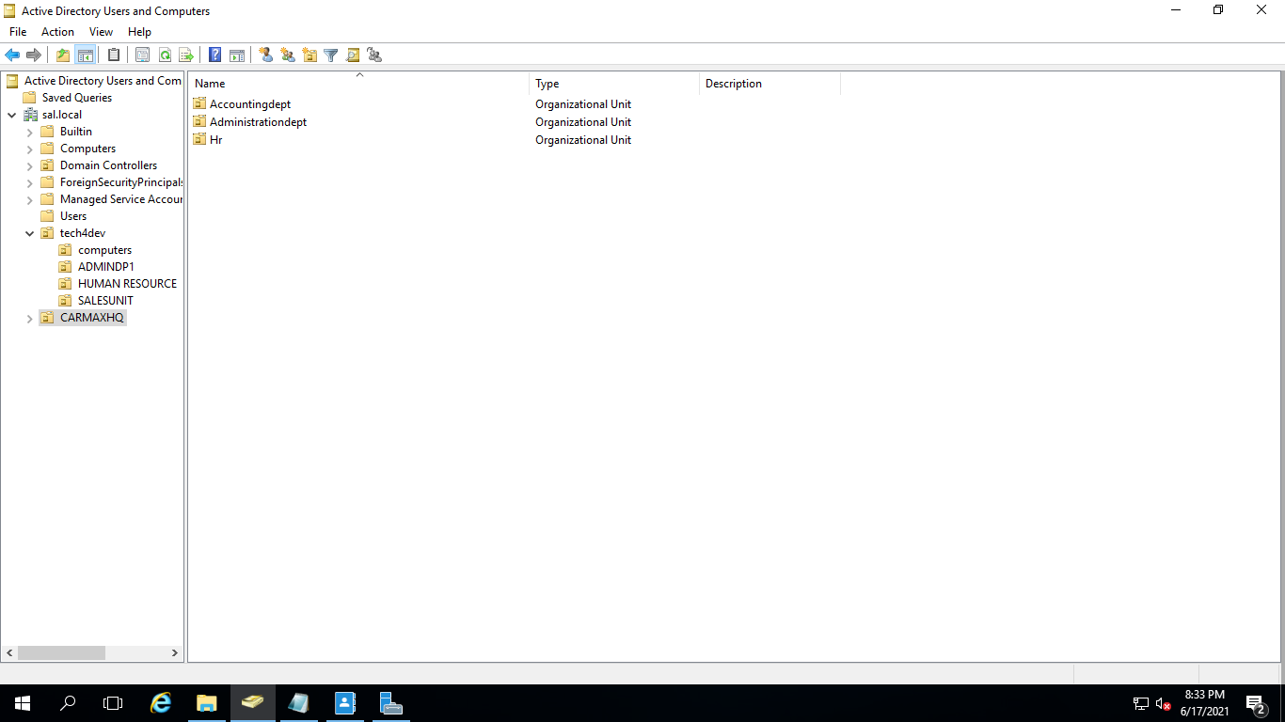

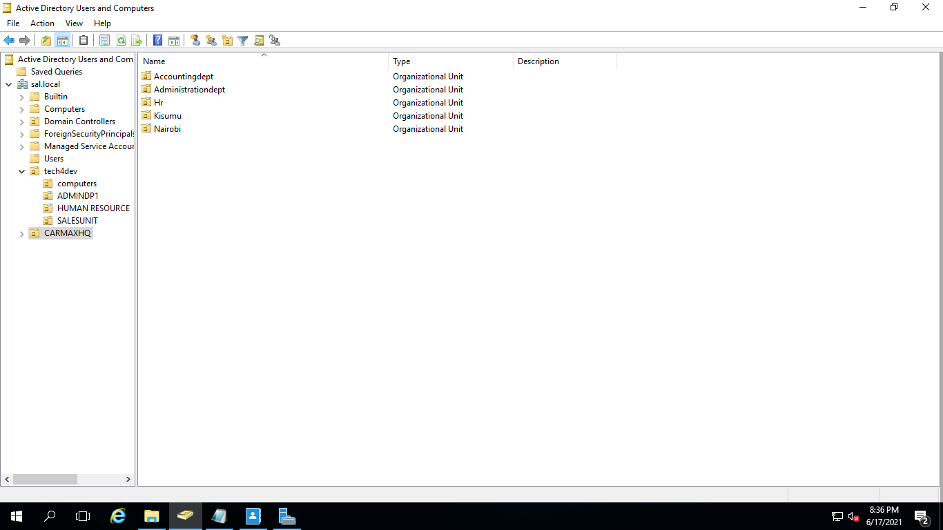

In each location I added groups of sales staff, mechanic staff and the management

For Nairobi :

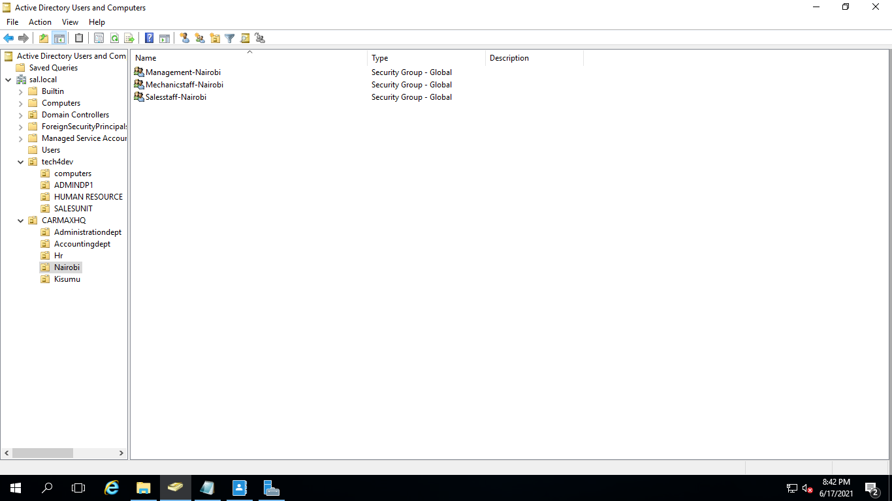

For Kisumu:

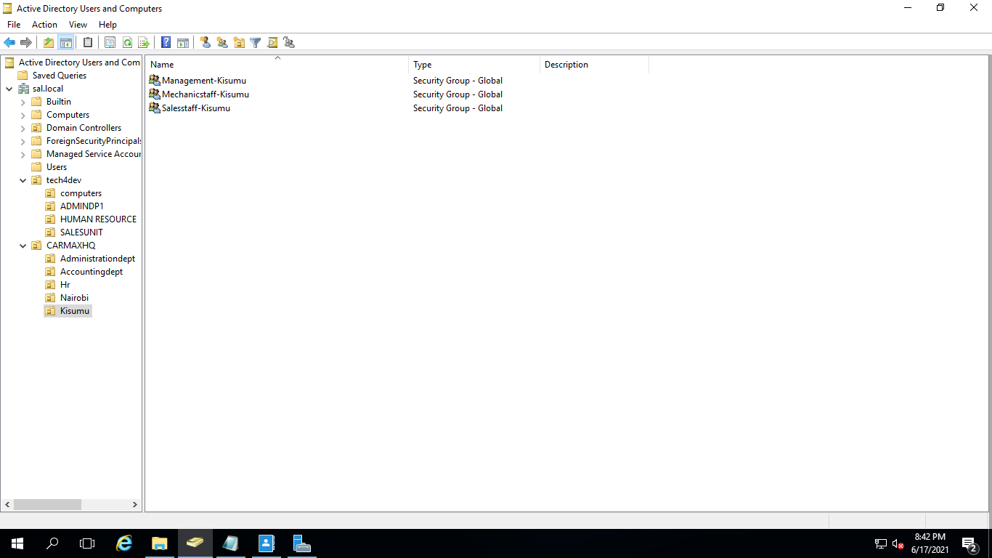

1. **Under each Unit add dummy users.**

In all groups and organizational units I added at least one user.

Rose in administration dept.

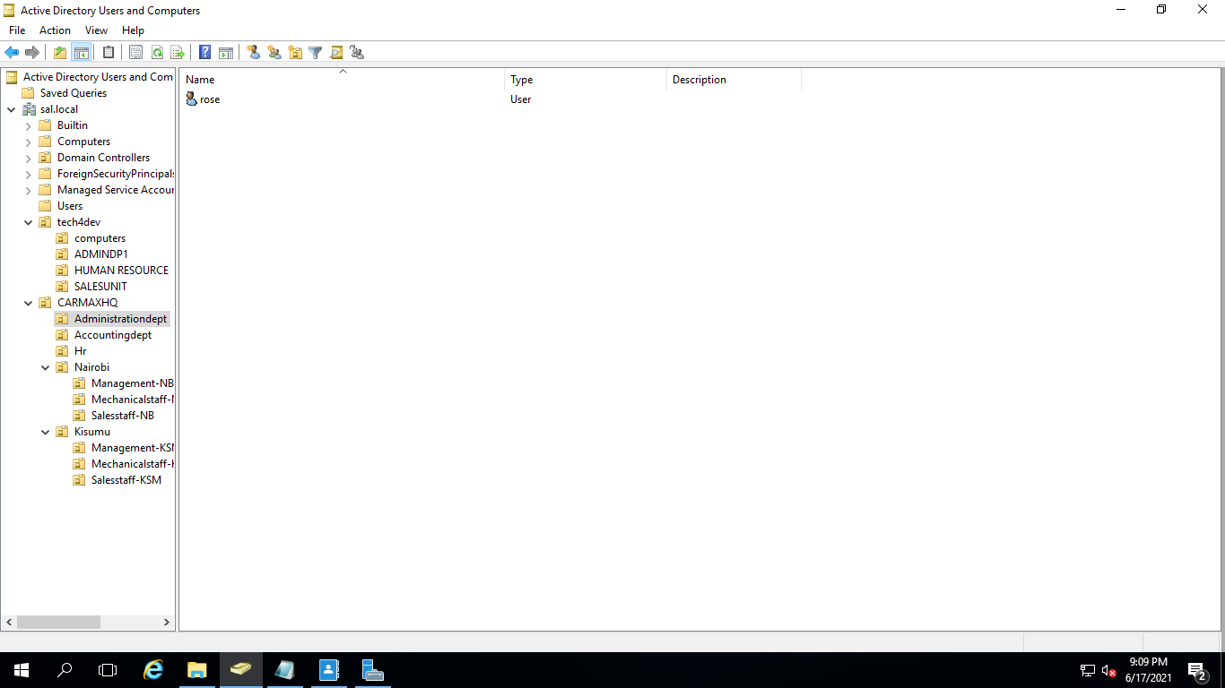

Selina in HR.

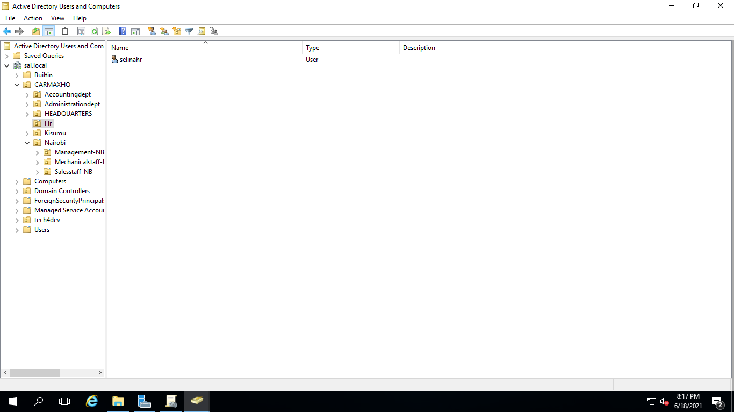

Kriss in accounting department.

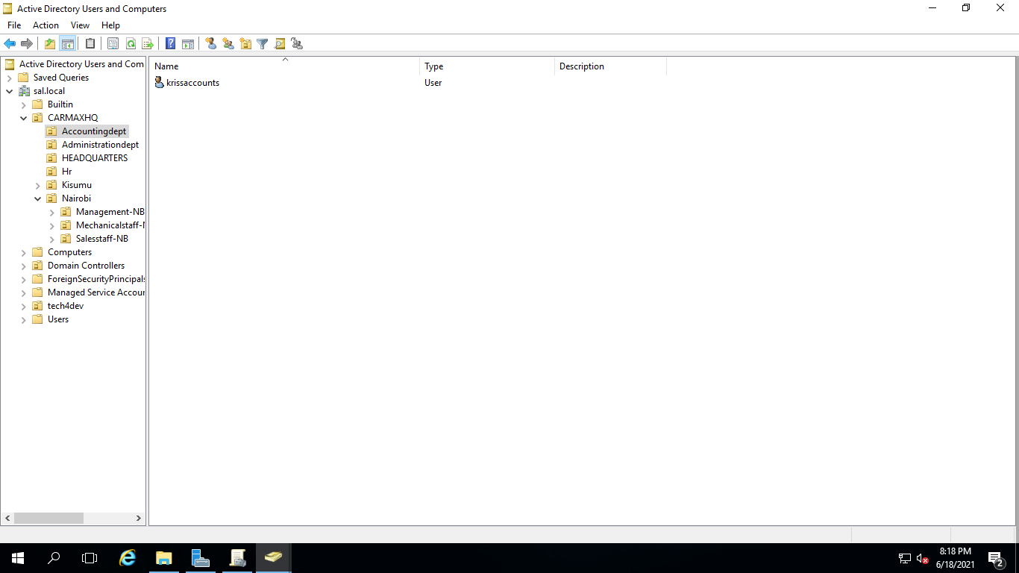

For Nairobi I added the following users:

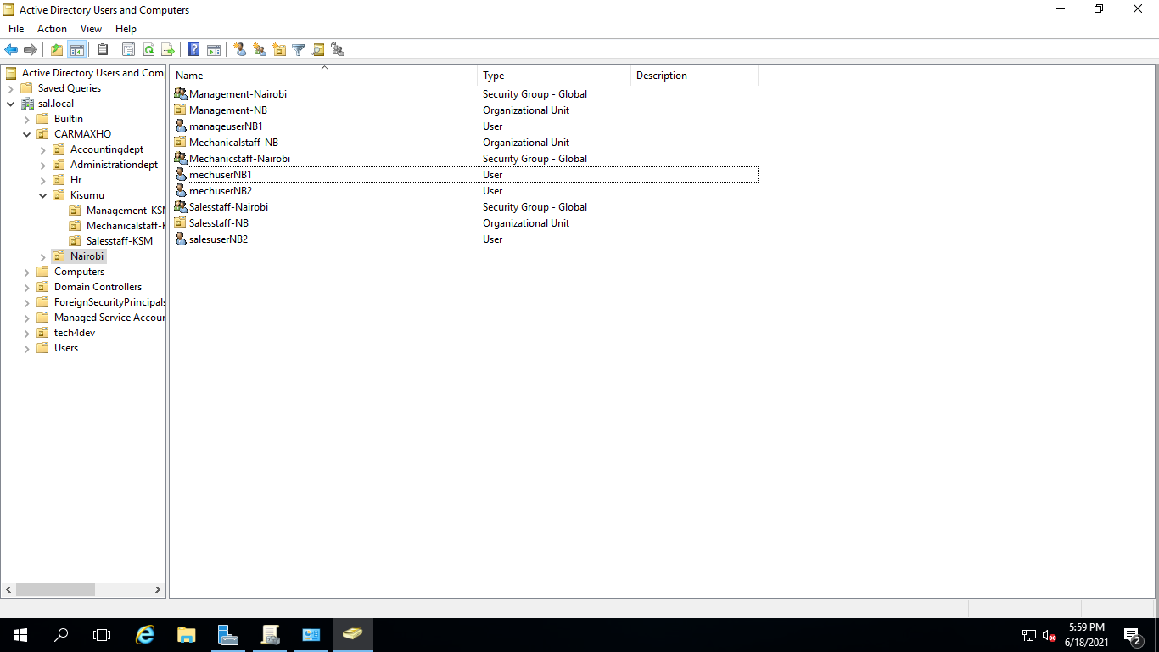

For Kisumu I added the following users:

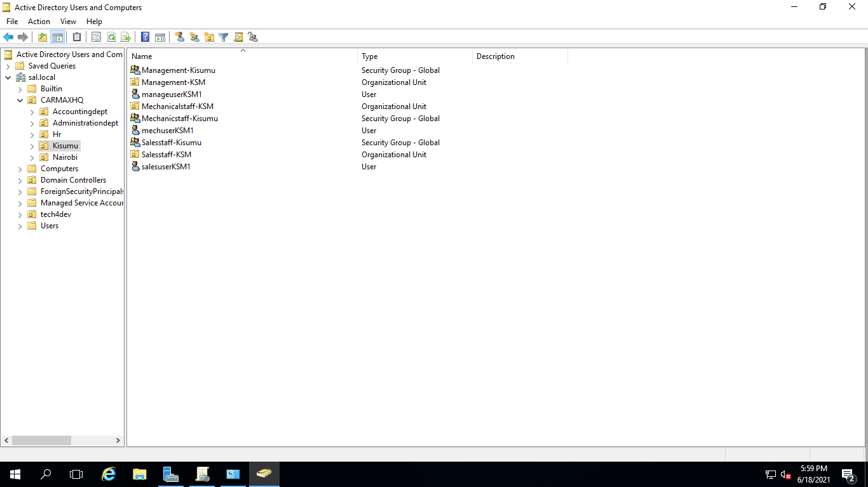

1. **Assuming a user in Sales Staff is promoted to Administrative Dept, give a description on how you will handle this and make sure the sales user is effectively transitioned to Administrative Unit**. *Please give a detailed description with accompanied screenshots.*

So I transferred salesuserNB1 to administrative department by right clicking on it and selecting move then choosing administrative department.

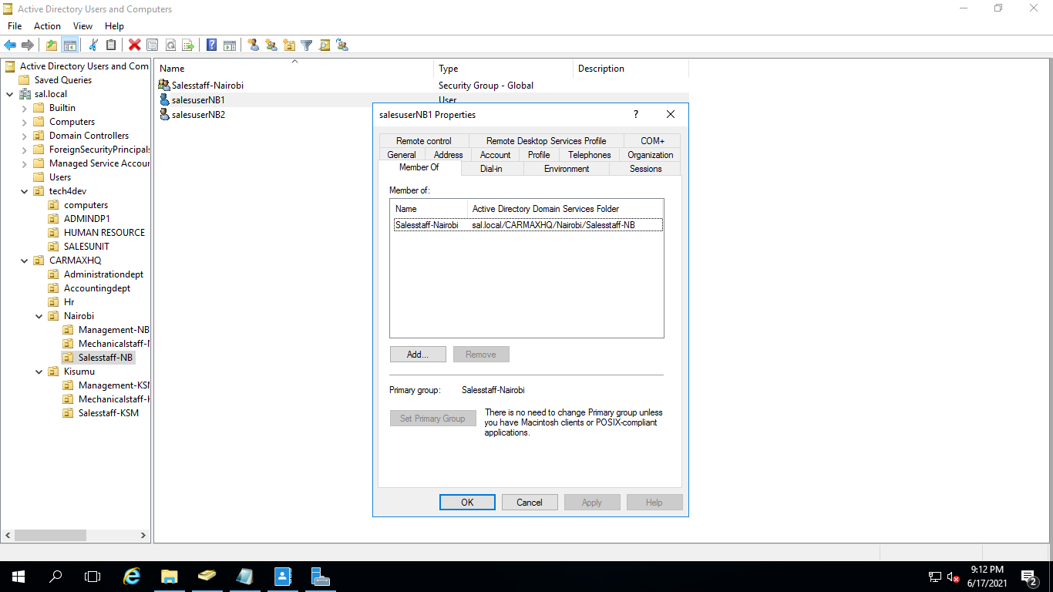

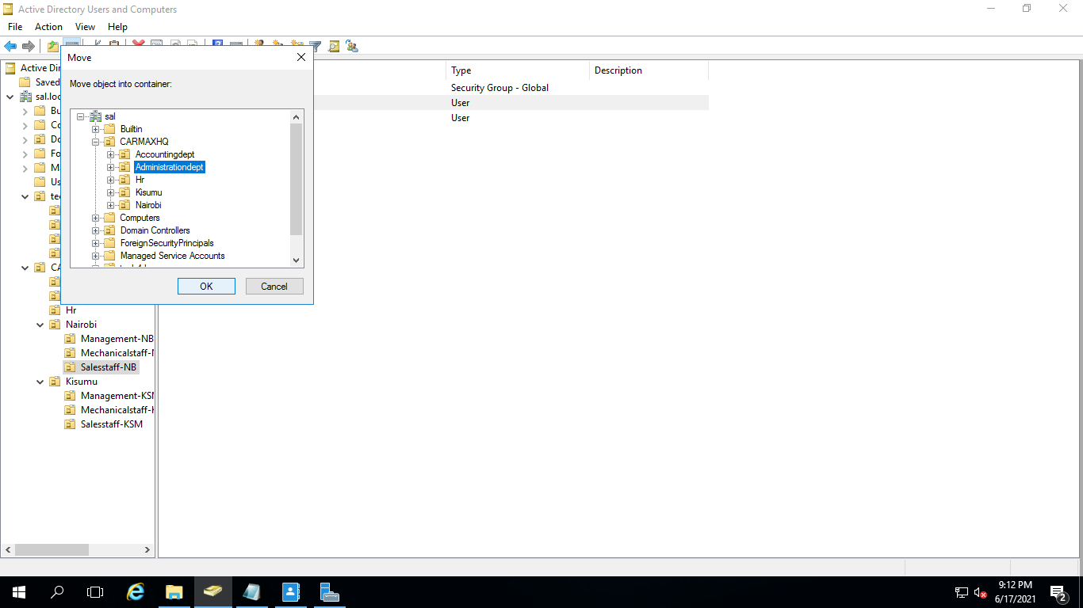

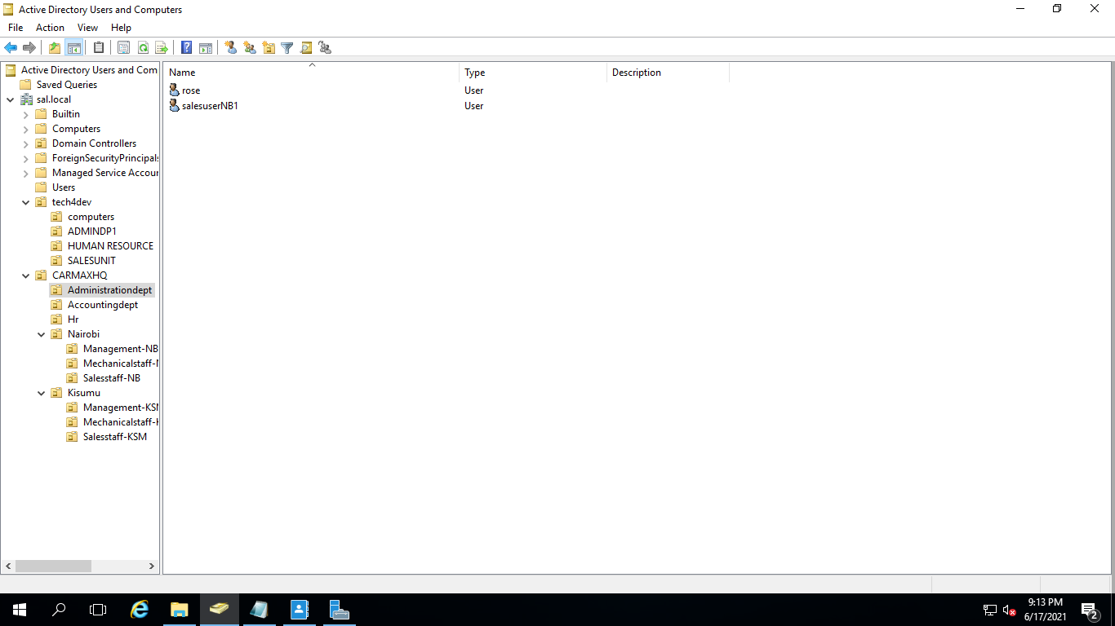

1. **Assuming “One dummy” user in Mechanic Staff has gone on leave for one month, give a detailed description of how you will ensure their user account is inactive and cannot be accessed by any other person during this one-month leave. This is to ensure unauthorized users to do not use that account to access the organization system.**

I will go to the users account and disable it then enable it when they are back. There are two ways to go about this that I know of :

* 1. Right click on the user then selecting disable.

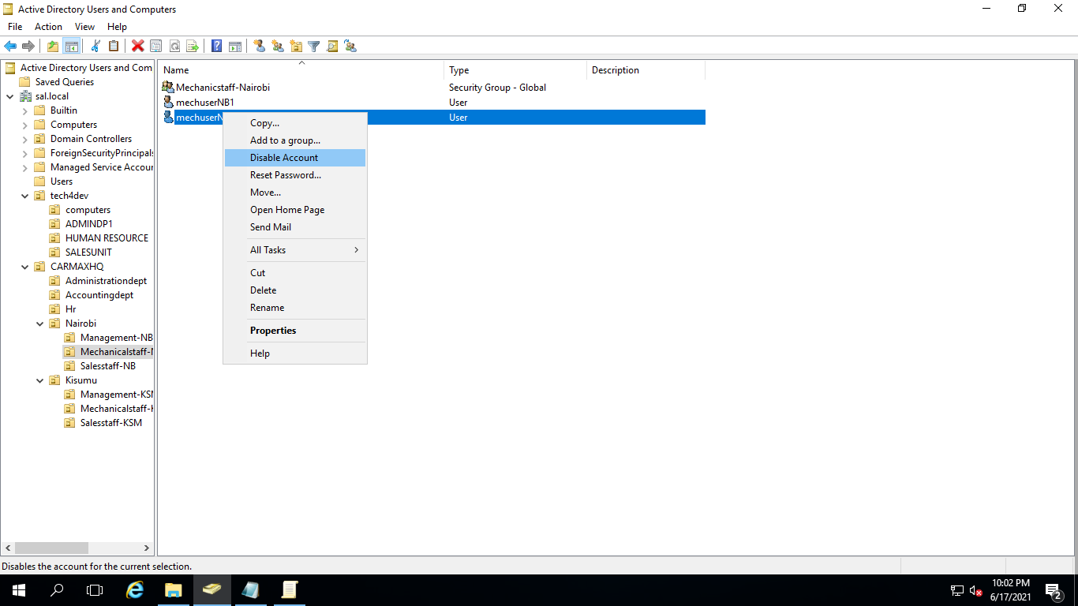

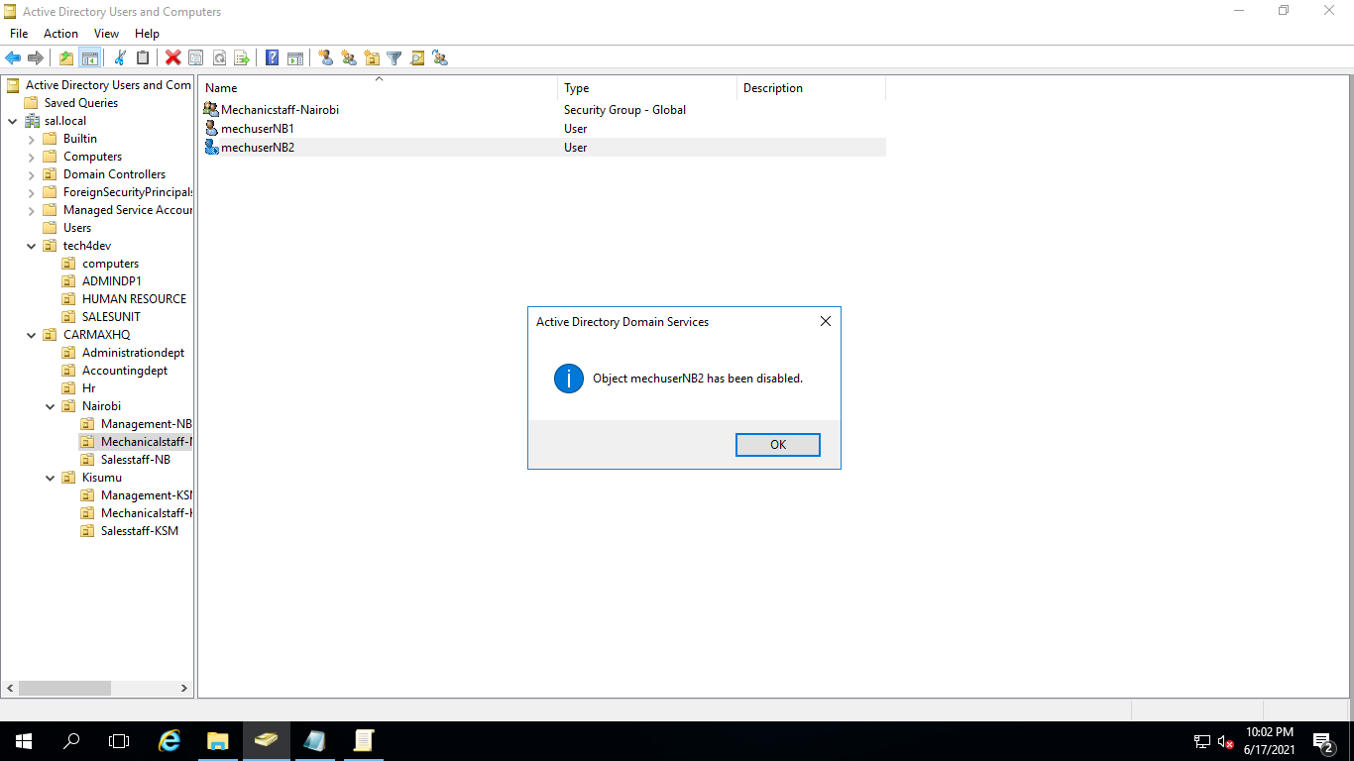

* 1. Right click go to properties and select accounts then go and check the checkbox for disabling.

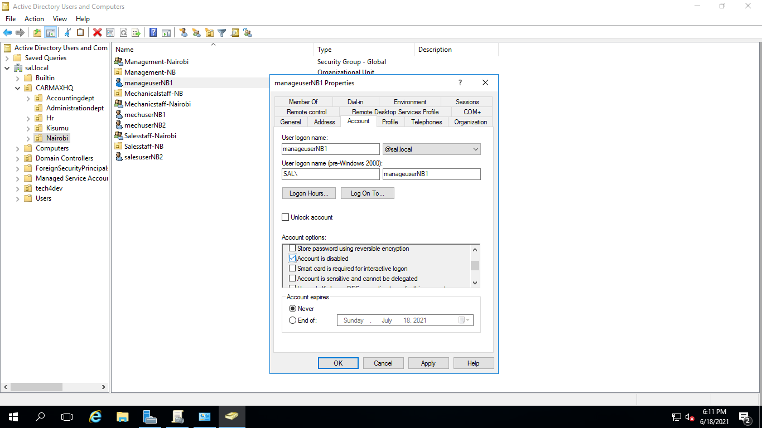

1. **In accounting Dept, we want to maintain high notes of security especially to the computers. Add a computer policy under Accounting Dept to ensure all computers are locked or disabled after 3 minutes of inactivity. The user has to login once again when back.**

To add the policy I went to server manager then tools then group policy management. I right clicked on CARMAXHQ then created a policy called inactivitytimeout. I right clicked on inactivitytimeout to edit it and change the interactive logon: machine inactivity limit properties to 3 minutes (180secs).

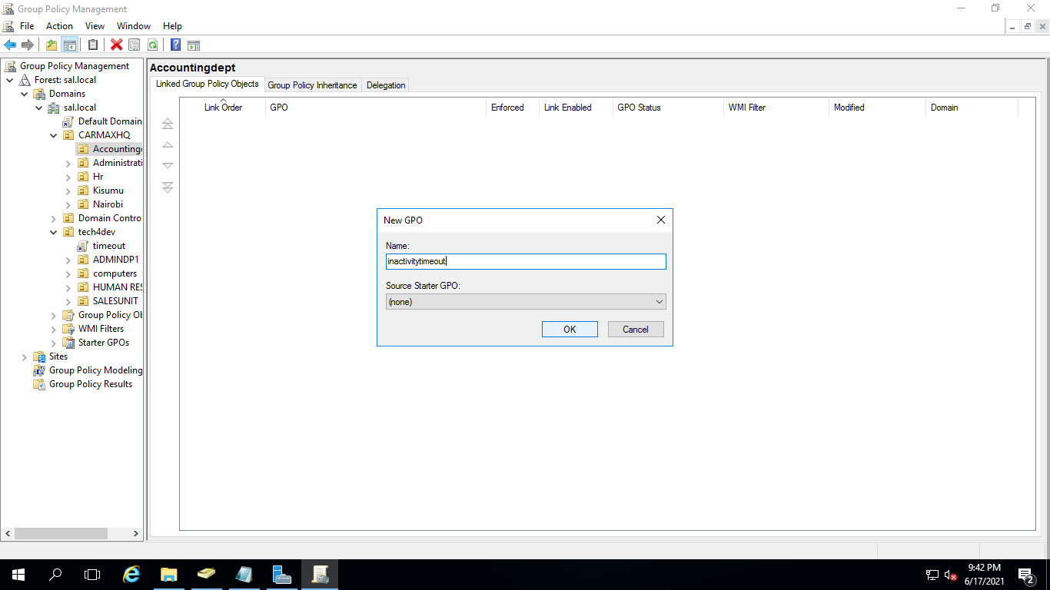

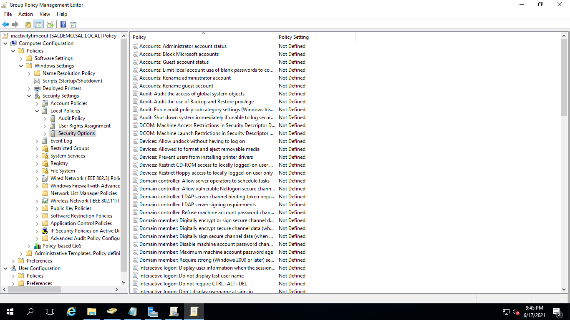

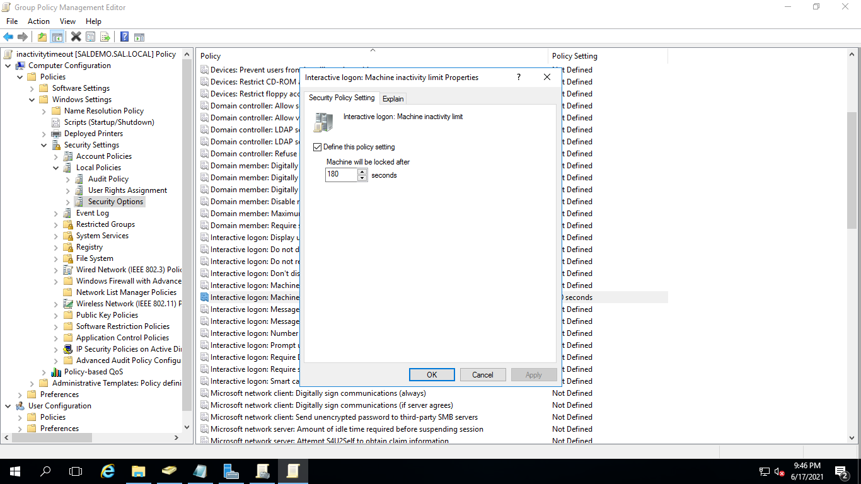

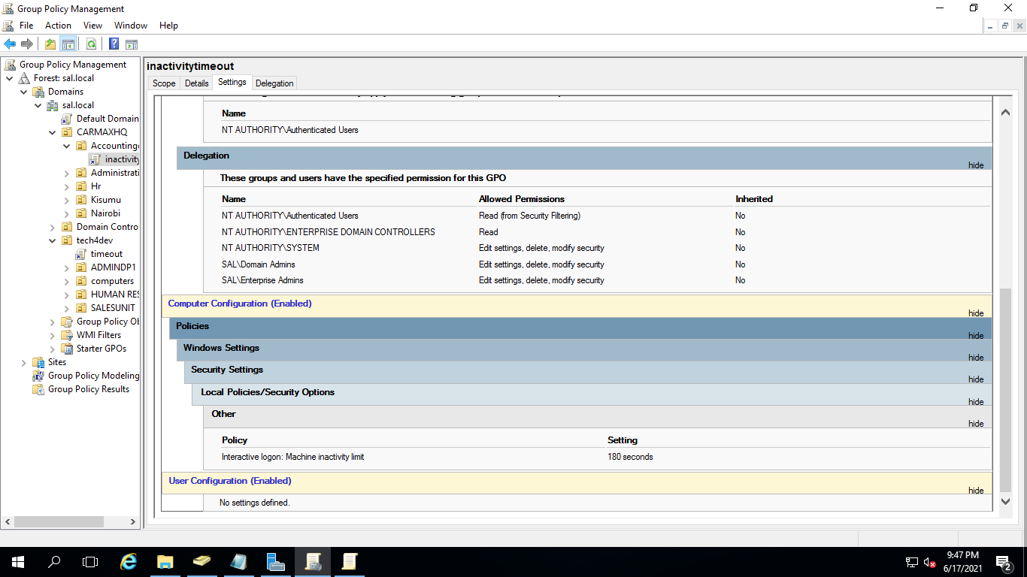

Polite Notice: Apologies for the unnecessary organizational units I could not manage to delete or alter them due to some permissions in azure.